Navigation:

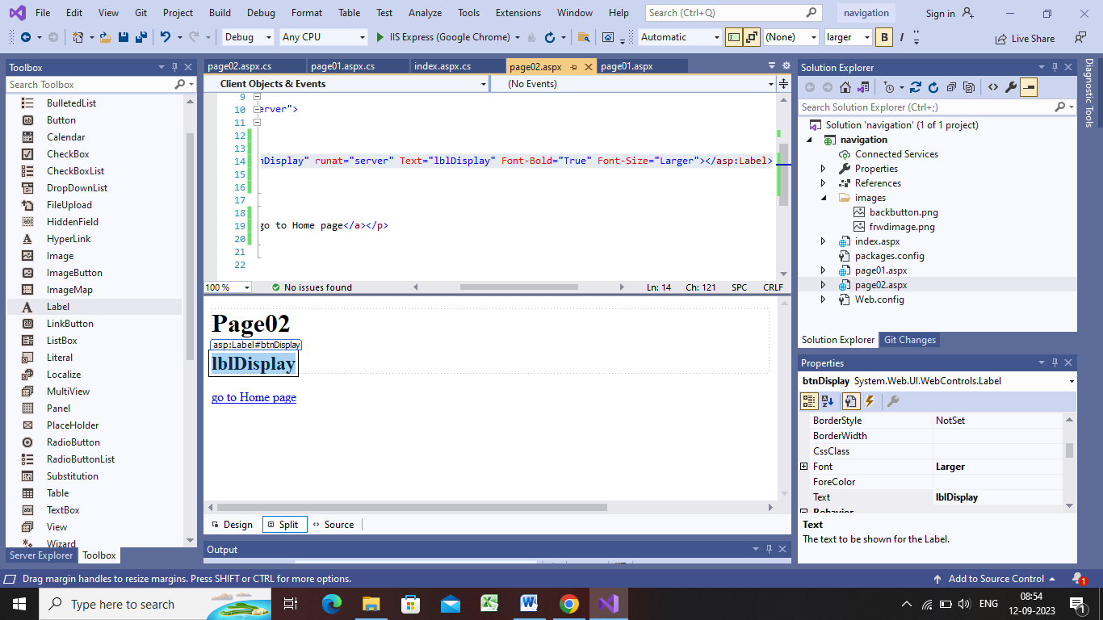

Step1:create new project->file->new->empty etc

Step2:project name Navigatio

Step3:right click on navigation->select add->newfolder->give it name images->copy two png img in images older

Step4:-right click on navigation->add web form->name:index.aspx->ok-><title>Home</title>

Step5:-right click on navigation->add web form->name:page02.aspx->ok-><title>page02</title>

Step6:right click on index page->set as start page

Step7:go to design page of index.aspx->write Home->enter->take linkbutton->go to page01->size->larger->id->lbtnGotopage01->backcolor->green->border->orange->borderstyde->outset->text->gotopage01

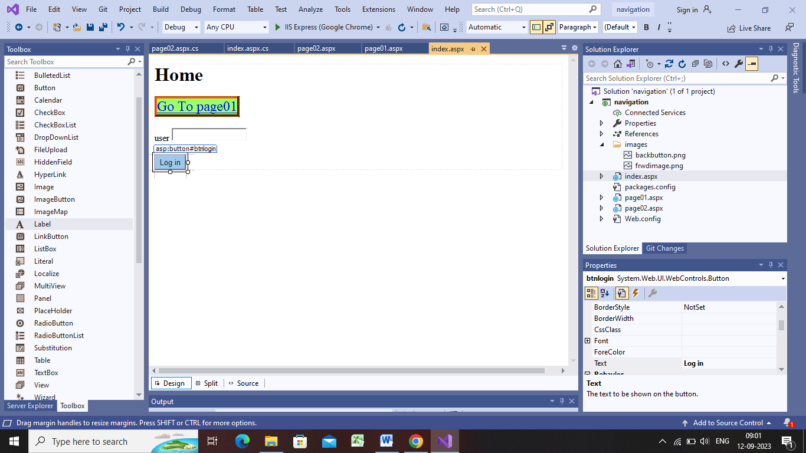

Step8:-double click on button->response.redirect(“page01.aspx”);

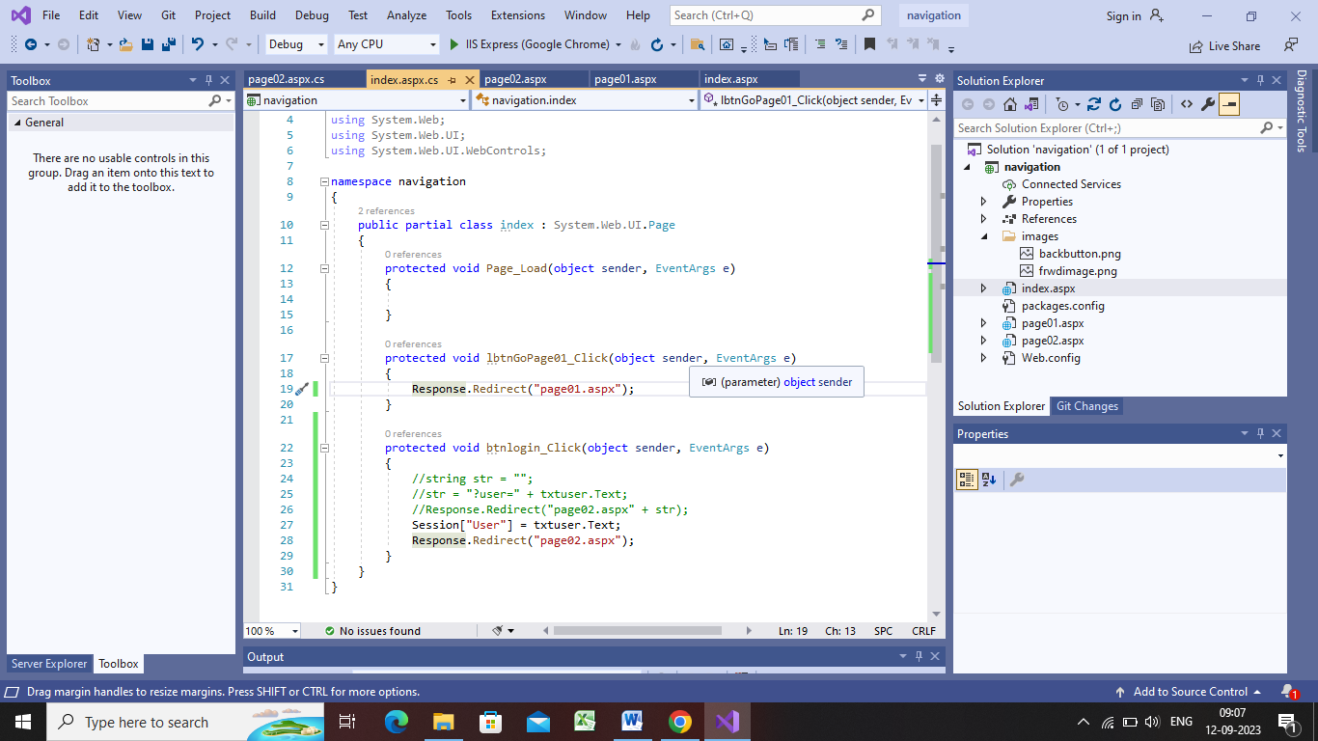

Step9:-ho to page01:->drag image ->name->home;>size:80,80,

Select image->format->convert to hyperlink->browse->index.aspx.

Step10:for image2 on page01 take hyperlink for frwd button->text proper gotopage02->font bold->

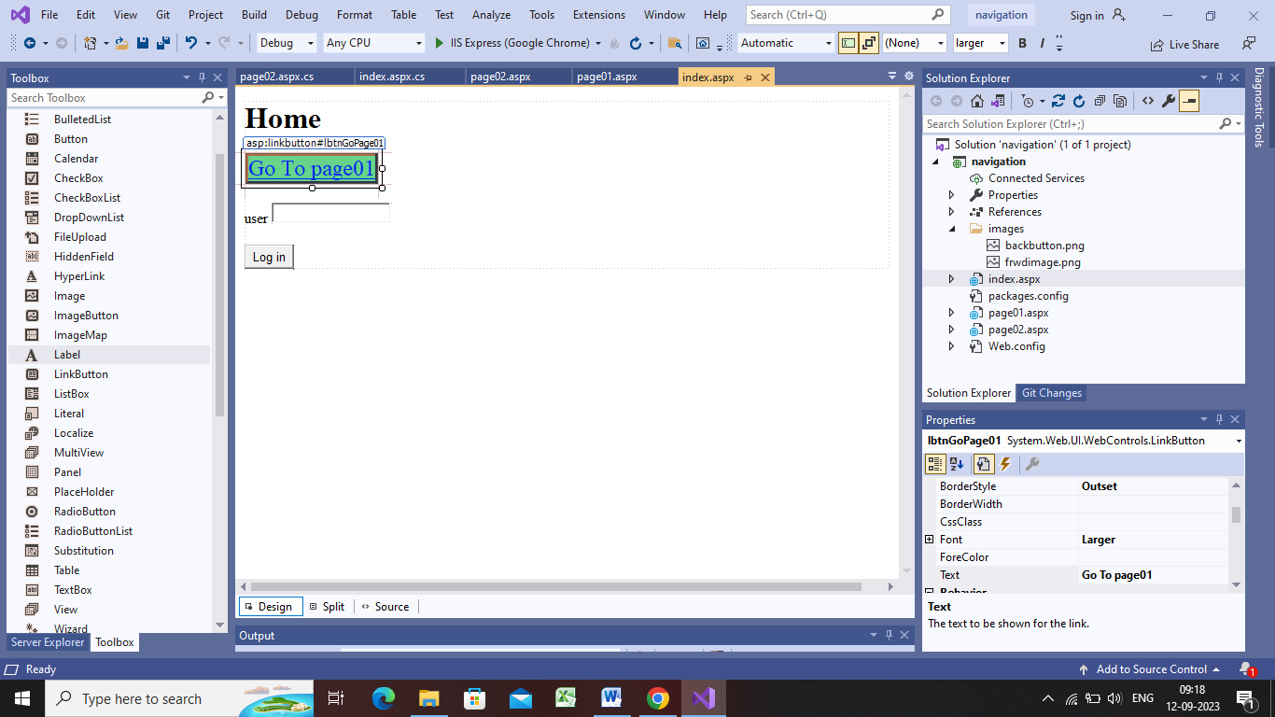

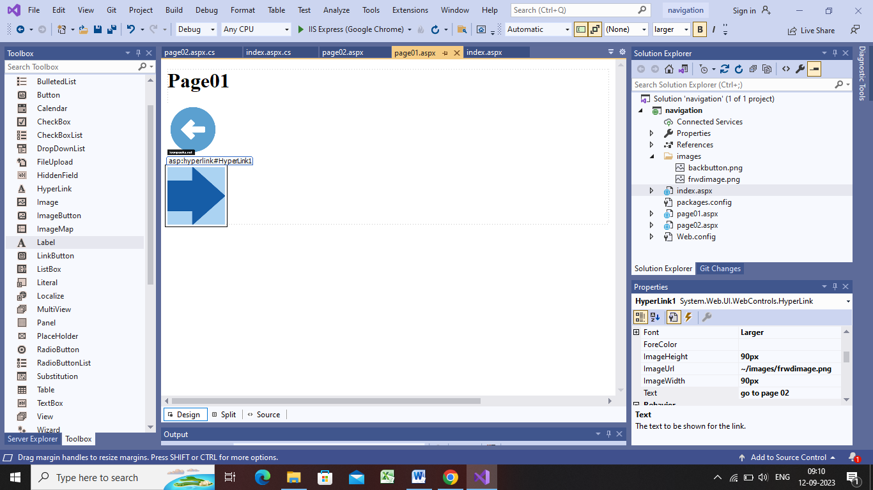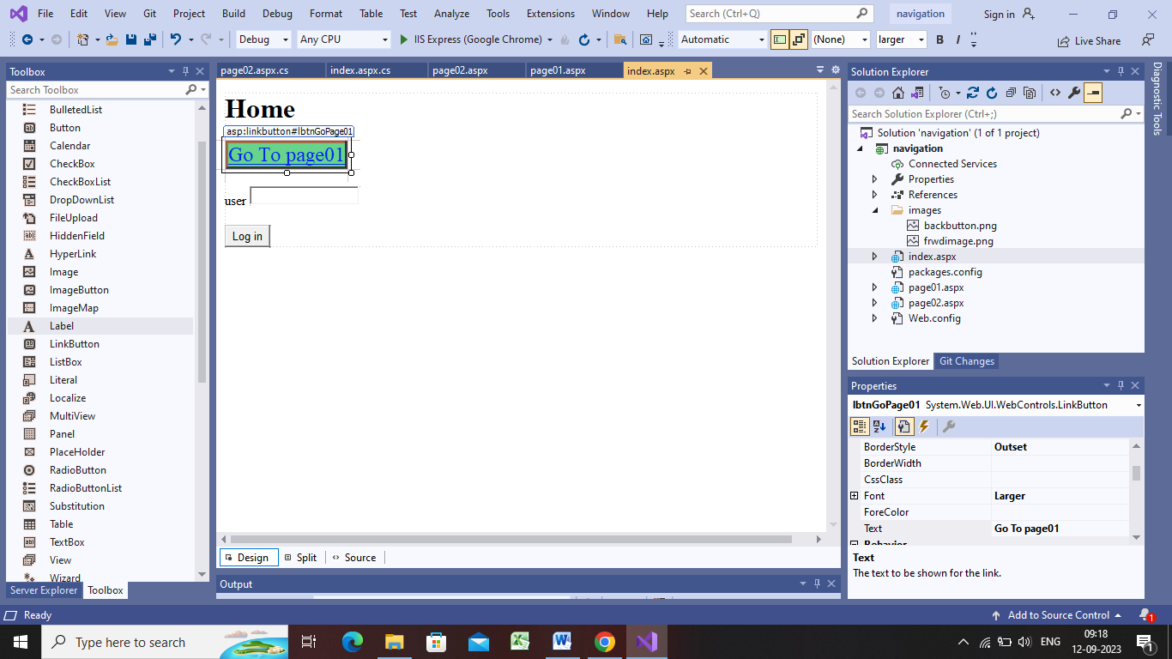

using System;

using System.Collections.Generic;

using System.Linq;

using System.Web;

using System.Web.UI;

using System.Web.UI.WebControls;

namespace navigation

{

public partial class index : System.Web.UI.Page

{

protected void Page_Load(object sender, EventArgs e)

{

}

protected void lbtnGoPage01_Click(object sender, EventArgs e)

{

Response.Redirect("page01.aspx");

}

protected void btnlogin_Click(object sender, EventArgs e)

{

//string str = "";

//str = "?user=" + txtuser.Text;

//Response.Redirect("page02.aspx" + str);

Session["User"] = txtuser.Text;

Response.Redirect("page02.aspx");

}

}

}

Pagre01:

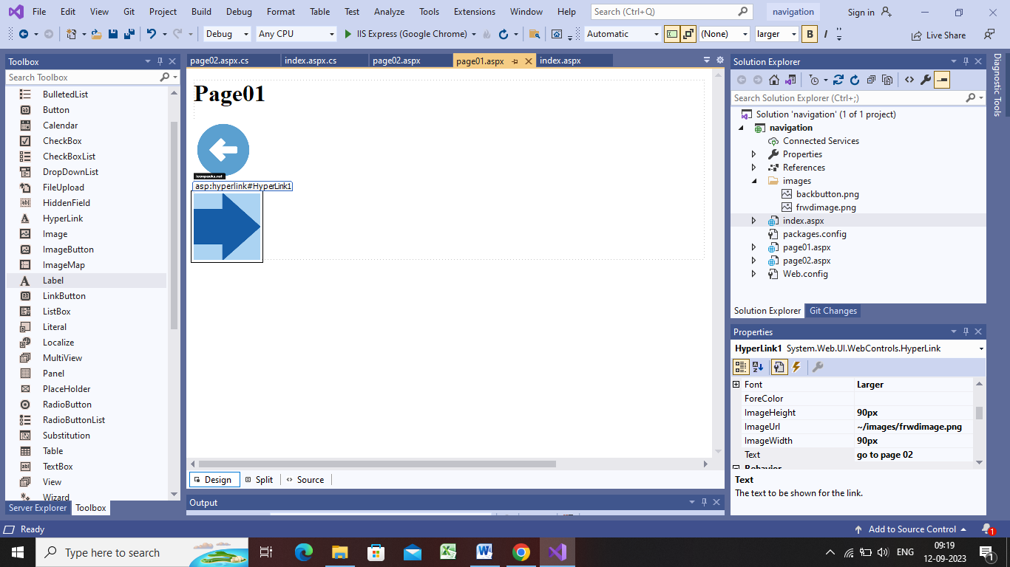

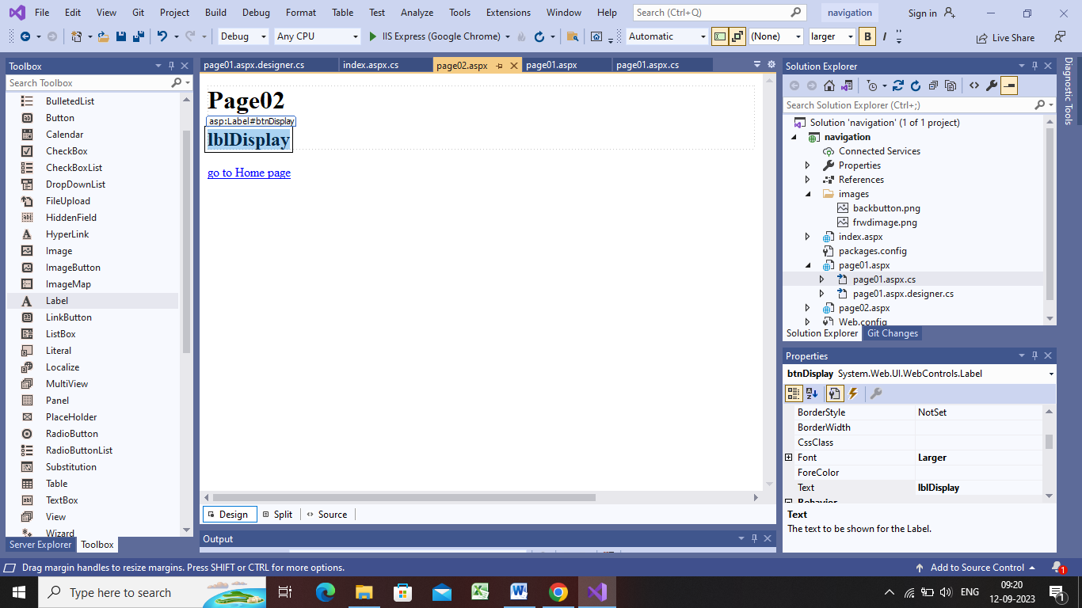

Page02.aspx

using System;

using System.Collections.Generic;

using System.Linq;

using System.Web;

using System.Web.UI;

using System.Web.UI.WebControls;

namespace navigation

{

public partial class page02 : System.Web.UI.Page

{

protected void Page_Load(object sender, EventArgs e)

{

if (!Page.IsPostBack)

{

//btnDisplay.Text = Request.QueryString["user"];

btnDisplay.Text = Session["user"].ToString();

}

}

}

}